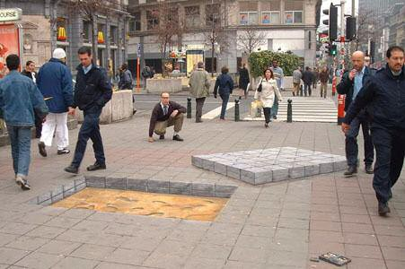

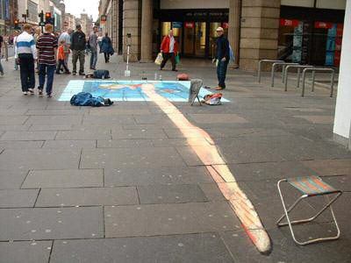

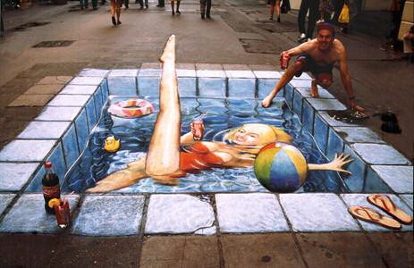

3D Illusions

Julian Beever is an English artist who’s famous for his art on the pavement of England, France,

Germany, USA and other countries.

The pavement drawings are anamorphous illusions drawn in a special distortion.

The images are drawn completely deforms, which give a 3D image when viewing on the right angle

… see for yourself it’s amazing!!!

www.julianbeever.net